Revision for Section A

**Arrays**

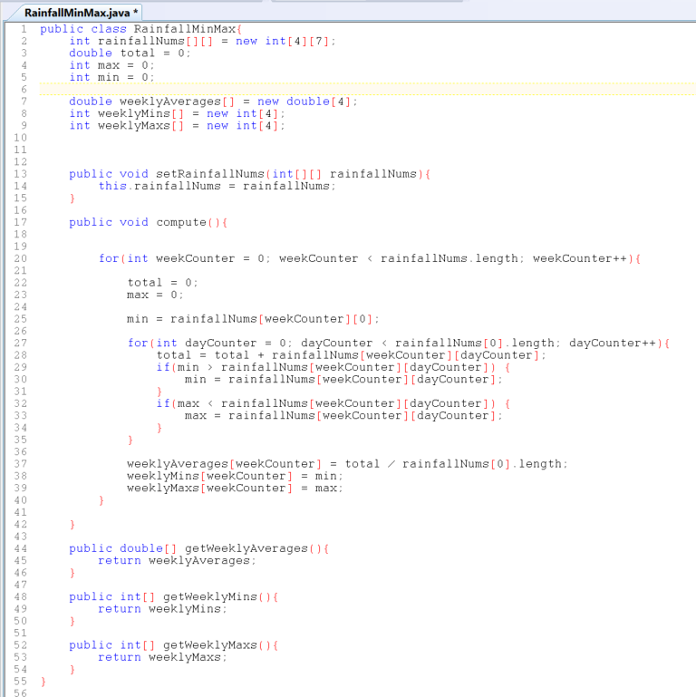

Questions

1. Explain the code in line 8?
   1. Creating an array of weeklyMins and declare it with 4
2. How many return types are there?
   1. There are 3 return types
3. What is the missing code in line 27?
   1. The missing code is dayCounter
4. Explain the code in line 29?
   1. Min variable is greater than the week and the day

**StringBuffers**

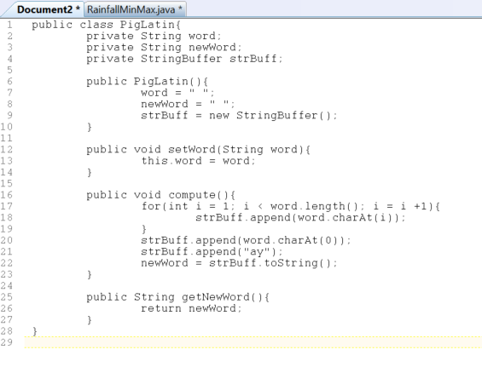

1. Explain the code in line 4?
   1. Declaring a stringbuffer (which allow you to alter text), give it a name and declare if private to the class.
2. There is some code missing in the constructor, please fill out the missing code?
   1. strBuff=new StringBuffer();
3. Explain the code in line 12?
   1. Returing in the word from the app class from the app class into instan class
4. What is line 18 doing?
   1. Appending a string into the StringBuffer at index 0
5. What is the return type of the getter?
   1. String
6. What is the output of this application?
   1. Assume it’s lisa - ayasil

**Characters and Strings**

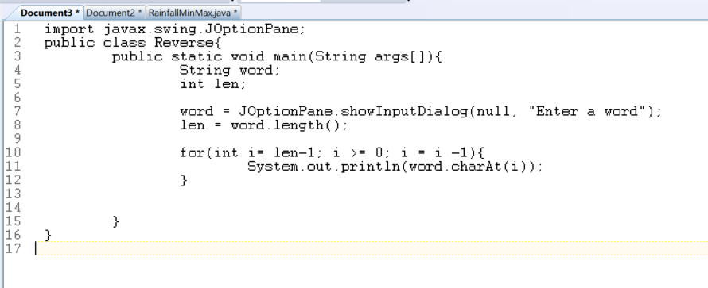

1. Explain the code in line 8?
   1. Gets the length of the word and stores it in len
2. Explain the for loop in line 10?
   1. Goes to the last character and works right up to the start of the word and goes backwards
3. What will be the result of this application?
   1. asil
4. What is the data type of the word inputted by the user?
   1. String